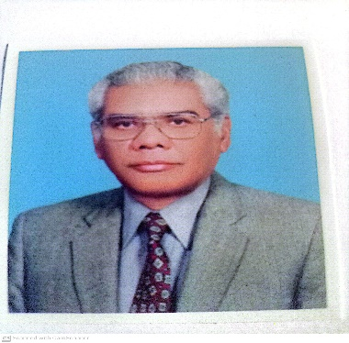

**Chem – 566**

**Advanced Topic in Physical Chemistry**

**My name is Dr. Athar Yaseen Khan. I am professor of physical chemistry. I did my M. Sc. From the University of Karachi, Ph. D. from the University of Southampton, and postdoc from the State University of New York, Binghamton.**

**I have been teaching physical chemistry courses in the FCCU since 2010.**

**This course has been designed to meet the deficiencies of postgraduate students in essential topics necessary for advance studies in all branches of chemistry. The course will include the following topics in depth:**

**1. Molecular symmetry and group and its applications**

**2. Theoretical aspects of molecular orbital calculations and examples**

**3. Thermodynamics and Chemical Kinetics (Application point of view)**

**4. Electrochemistry & Cyclic voltammetry and study of redox processes**

**As it is clear from the topics, this course will prepare students to apply the concepts and interpret the results of their research.**

**While preparing the course, it has been kept in mind that there will be a large number of students from biology background taking this course and who will need such material in their further studies and research.**

**I welcome students in this course and assure them of substance and quality.**