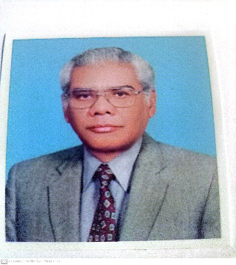

**Chem-170**

**Introductory Physical Chemistry**

**My name is Dr. Athar Yaseen Khan. I am professor of physical chemistry. I did my M. Sc. From the University of Karachi, Ph. D. from the University of Southampton, and postdoc from the State University of New York, Binghamton.**

**This course is designed to meet the requirements of physical chemistry for students majoring in biology, environmental sciences, and physics. The course also provides a sound basis for higher level courses in physical chemistry to students majoring in chemistry. The course covers the following topics:**

**1. Gases: gas laws and applications, ideal gas equation, van der Waal equation.**

**2. Thermochemistry: internal energy, enthalpy and applications of the first law of thermodynamics**

**3. Chemical Kinetics: first and second order reactions**

**4. Liquid state: properties of liquids (viscosity, surface tension)**

**5. Solid State: structure of metals and properties.**

**6. Solutions; concentration units and interconversion.**

**7. Atomic Structure: elementary concepts of Schroedinger equation (s, p, d, f orbitals), particle in a 1-D box.**

**I recommend this course to all students specially from biology, chemistry and environmental sciences to register for this course to enhance their understanding in other courses.**