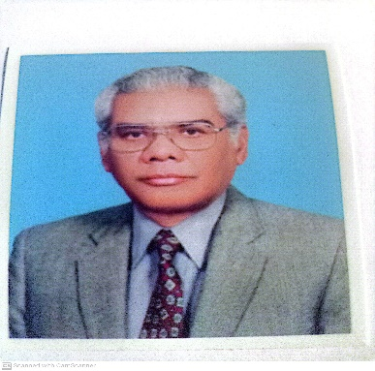

Instructor: Dr. Athar Yaseen Khan

Professor of Physical Chemistry

**Chem-763: Electroanalytical Techniques**

This course will deal with modern electroanalytical techniques and devices. The objective of the course is to provide a sound understanding of the fundamentals of electrode reactions and the principles of electrochemical methods and their potential applications in solving analytical problems.

Electroanalytical techniques are based on the interplay between electricity and chemistry through measurement of electrical quantities – current, potential and charge and their relationship with chemical change. The areas of applications include environmental monitoring, industrial quality control, and biomedical analysis. Recent advances in the field are development of ultramicroelectrodes, design of tailored interfaces and molecular monolayers, coupling of biological components and electrochemical transducers, synthesis of ionophores and receptors containing cavities of molecular size to mention a few.

Electrochemical processes take place at the electrode-solution interface. Electroanalytical techniques differ from one another in the from of the electrical signal used for quantitation. The two principal type of electroanalytical measurement techniques are potentiometric and potentiostatic. Both techniques require two or three electrodes dipped in solution containing an electrolyte.

Electroanalytical techniques which will be dealt with are: Cyclic Voltammetry, Chronoamperometry, Pulse Techniques, Polarography, Stripping Analysis.

Practical Considerations: Electrochemical Cells, Electrodes, Solvents and Electrolytes, Instrumentation

Applications: Sensors, Nanotechnology

Evaluation: Assignments (20), Quizzes (20), Mid Term 25), (Final